Digital Book Apps
Free Books | 4-12 | 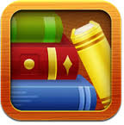
Kindle | All
iBooks | All | 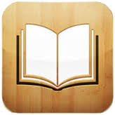
100 Great Short Stories | P-8
Newspapers for iPads | 6-12
Curious George at the Zoo | P-5 | 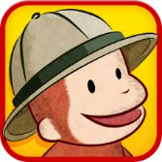
Read Me Stories 30 Book Library | P-5 | 