Writing Apps
Sentence Builder | K-5 | 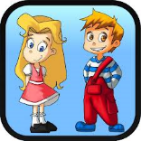
Handwriting Without Tears: Wet-Dry-Try Capital Letter & Numbers | P-3 | 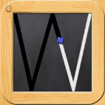
iWrite Words | P-1 | 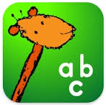
Rainbow Sentences | P-5 | 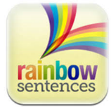
Typ-O HD – Writing is for Everybody! | 2-12 | 